### Yo Teach! is a free online tool for holding virtual chats with all your students, including many additional tools and features. For more information see [Yo Teach!](http://palms.polyu.edu.hk/educational-apps/yoteach/)

### **Yo Teach! (many participants)**

* Go to <https://yoteachapp.com/>
* Add a **Title** (no spaces) under the Make Room block
* Optional settings:
  + (Recommended) Check **Hide from Search Result** will hide your room from search results so that people cannot find it without being given its direct URL
  + **Enable admin features** (see <https://youtu.be/o6m6BErGnLU>)
  + (Not recommended) **Enable entry password**
* Click **Create Room** button

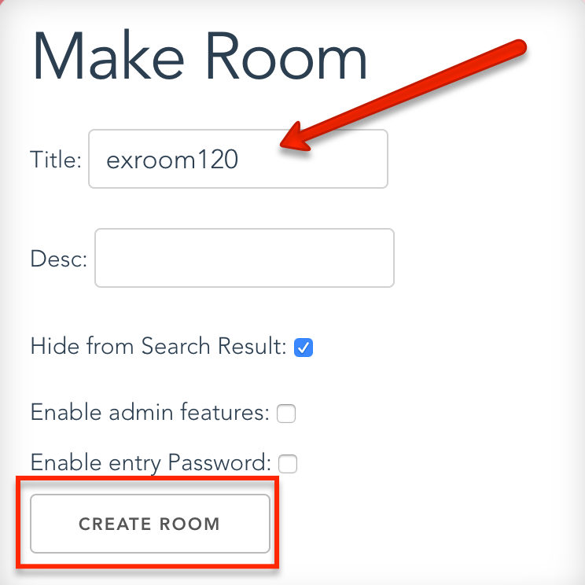

* Enter a **Nickname**, add a check to agree to the terms, and click **Submit**
* **Copy** the link to the room



* Add the link in **Moodle as a** [**URL resource**](http://ctl-unca.org/moodle3/adding-urls-to-your-moodle-page/)
* **To participate in the chat**
  + Type in the Message window
  + Click the “airplane” button to add your message to the chat window

